Operating Systems Lab Task

Name: Ahmed Kasteer

Roll Number: 20F-0336

Section: 4D

1. VM WARE

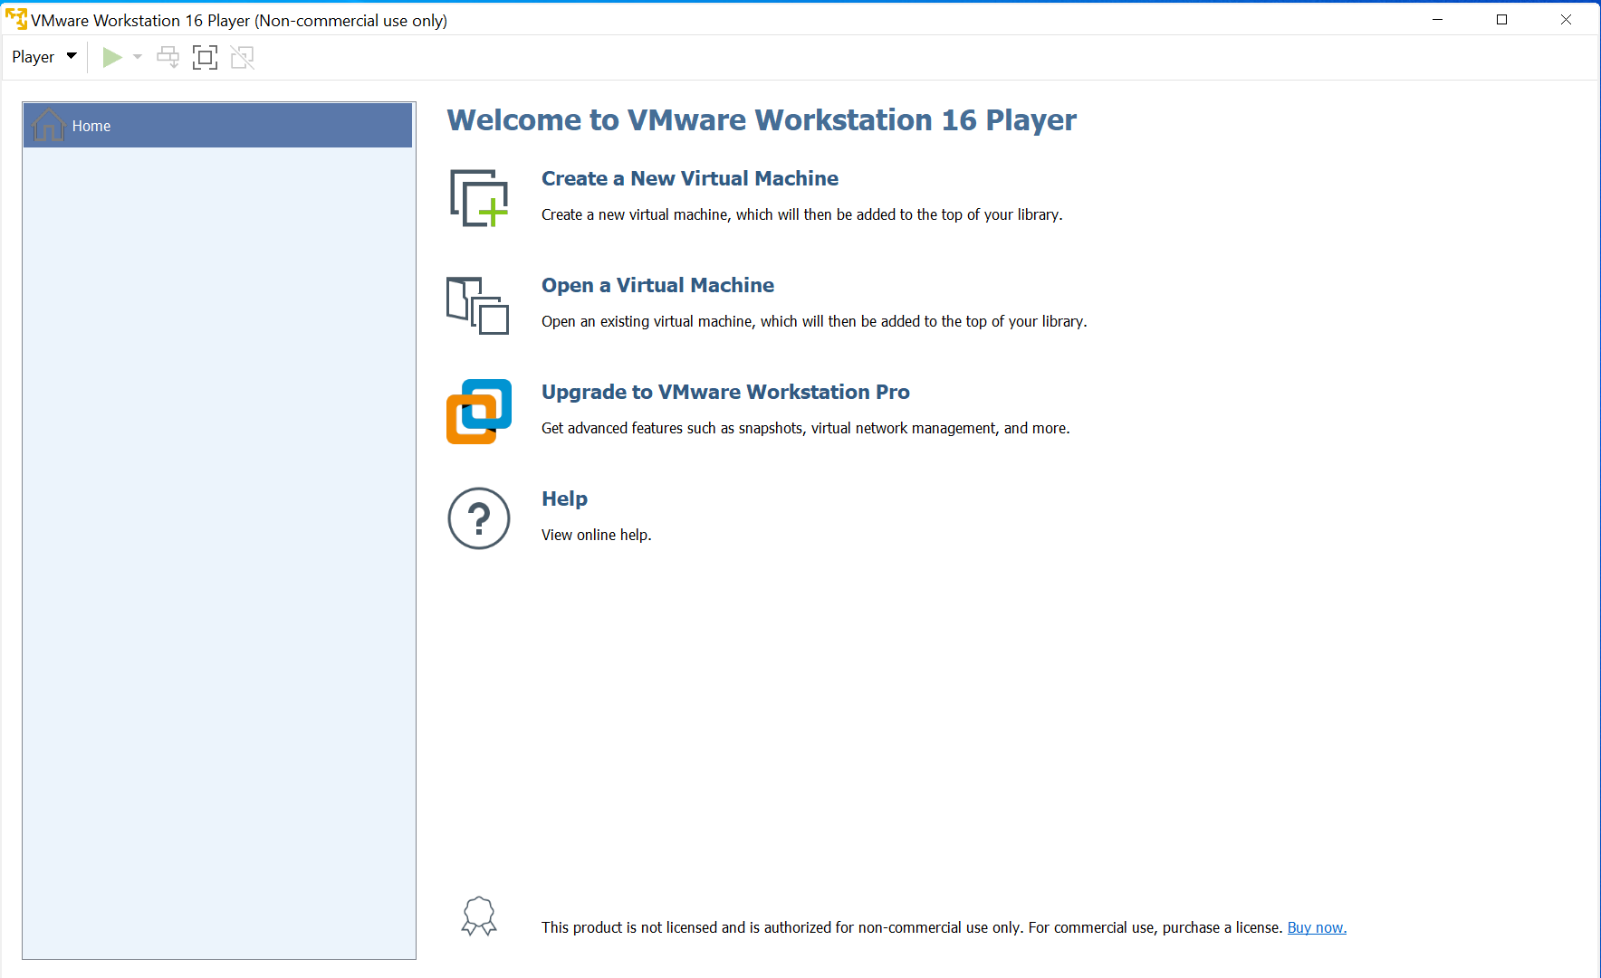

Default Home screen for VM Ware 16 updated to latest version.

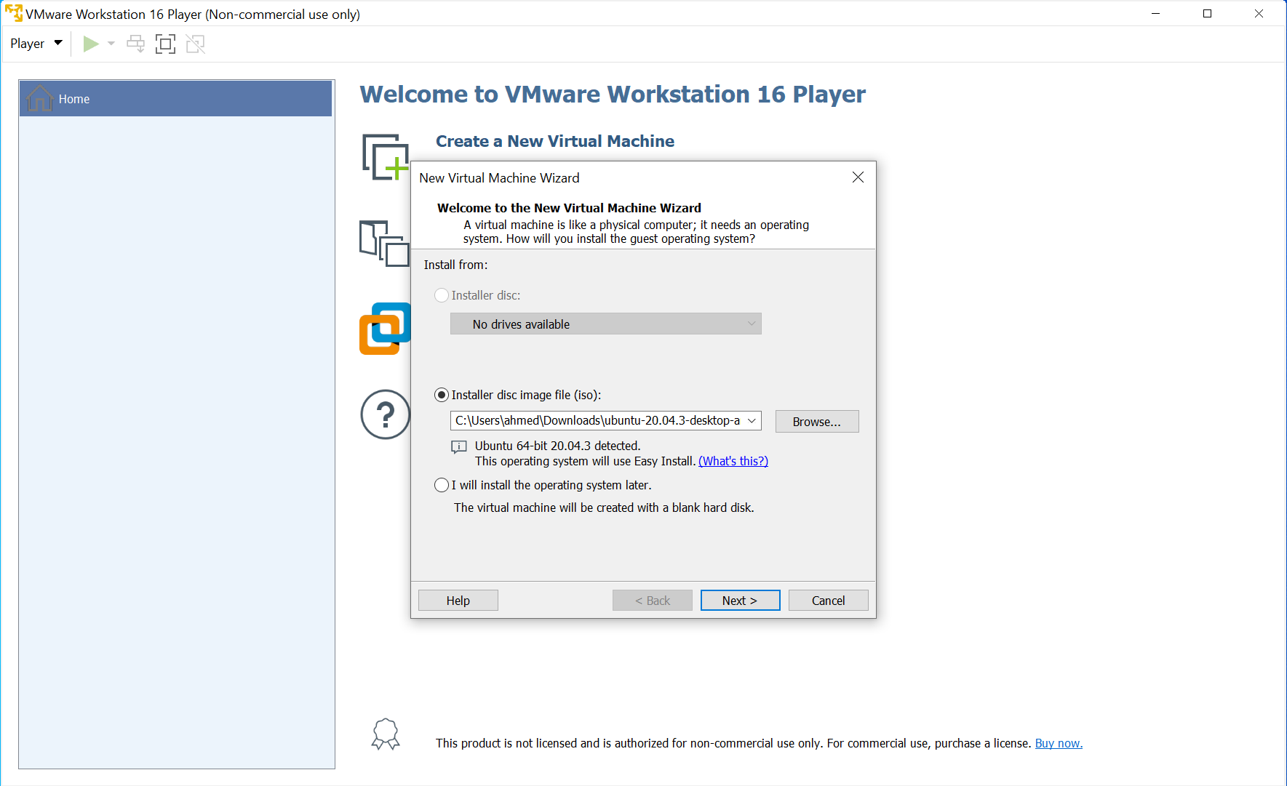

Selecting Ubuntu ISO Image. Ubuntu Version 20.04.3 for Desktop.

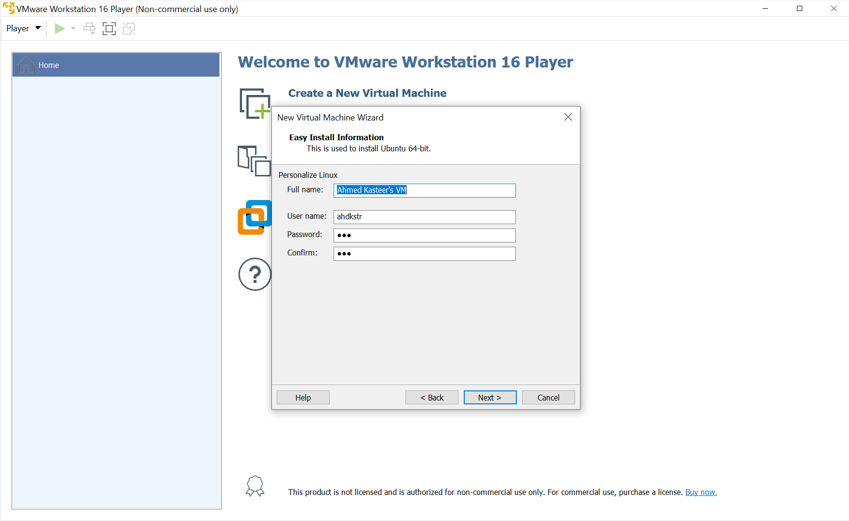

Entering credentials for Virtual Machine Setup.

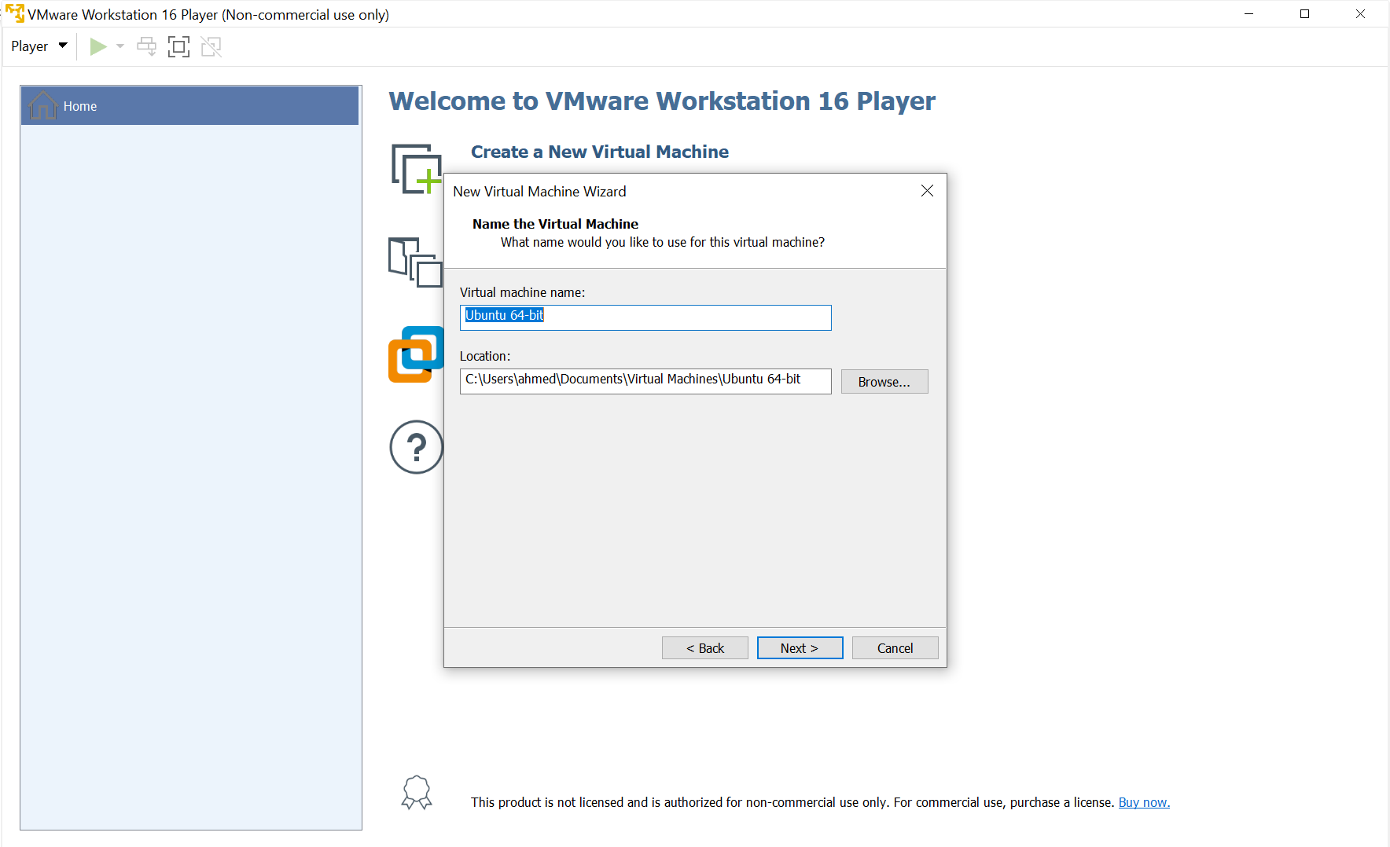

Naming Virtual Machine.

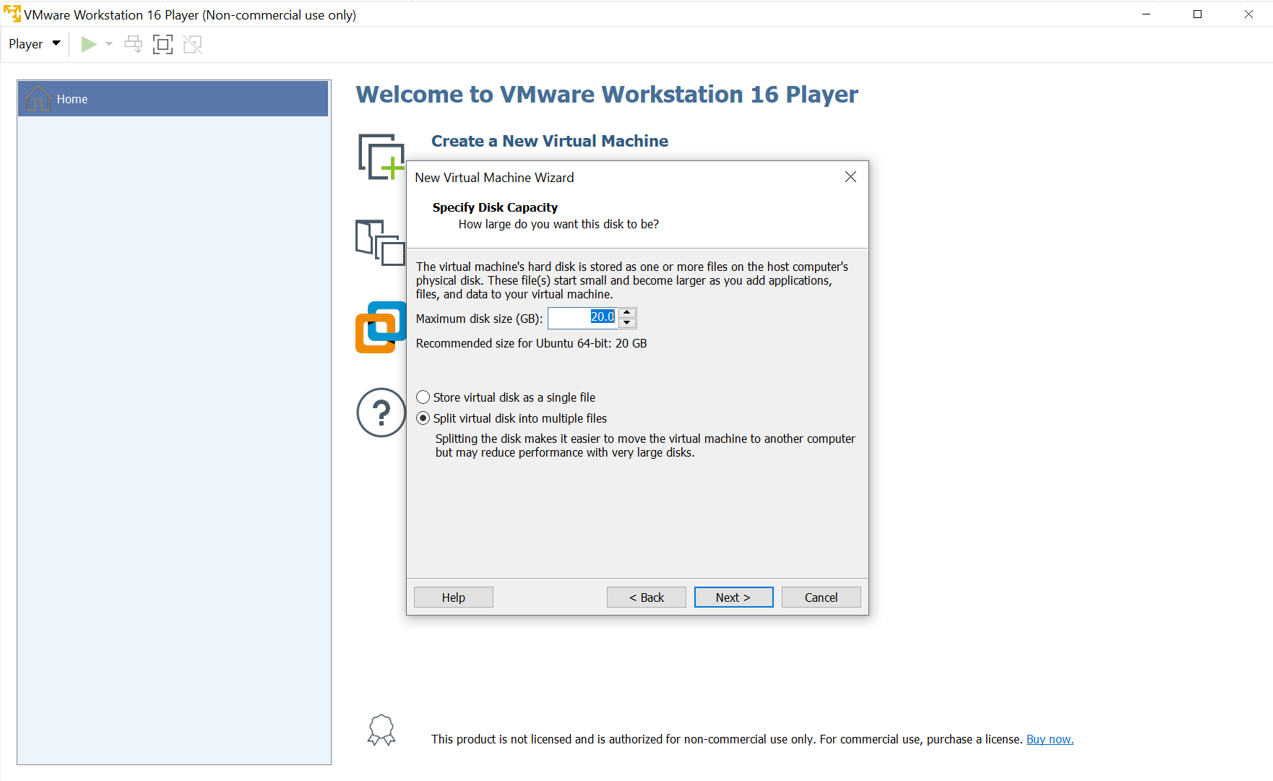

Keeping default size of disk storage for Ubuntu Operating System.

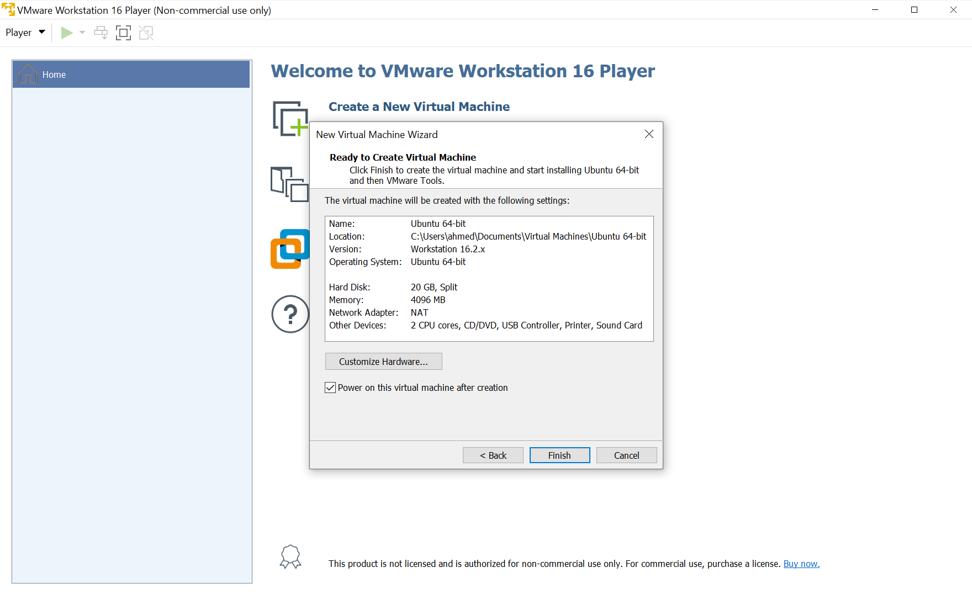

Clicking bottom left Customize Hardware to allocate number of CPU cores and RAM for our operating system.

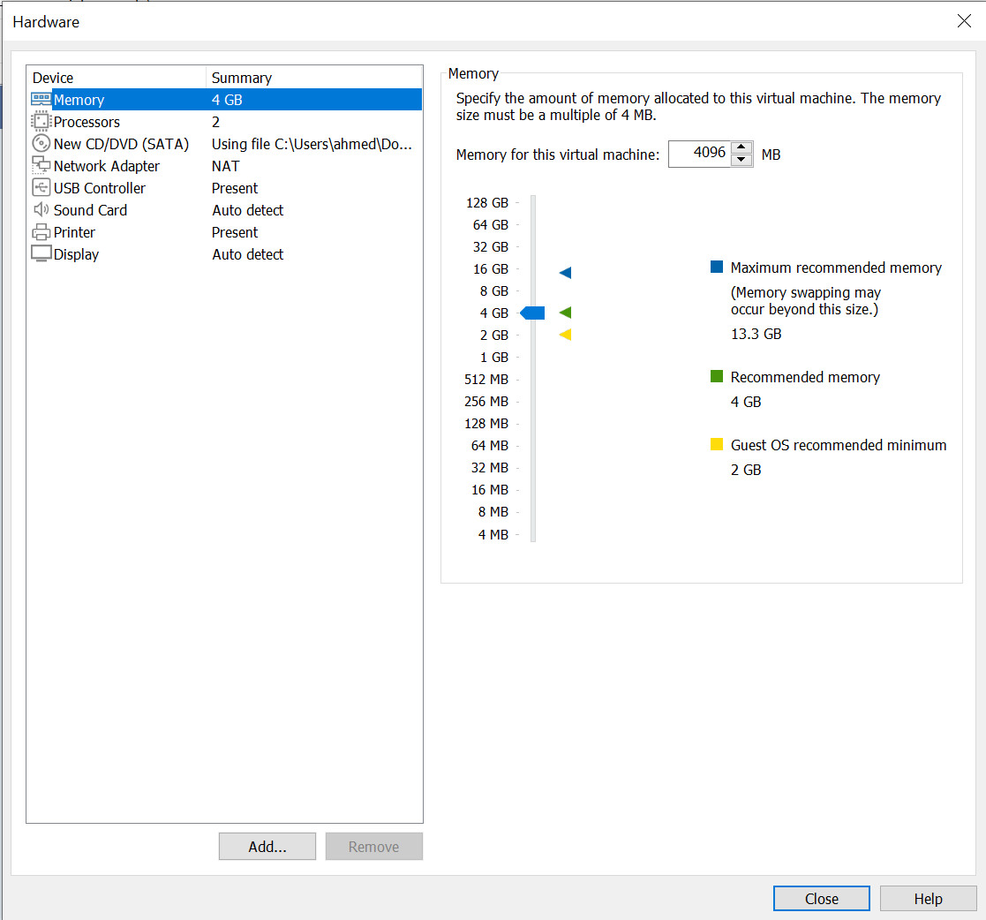

4GB enough for Ubuntu OS usage.

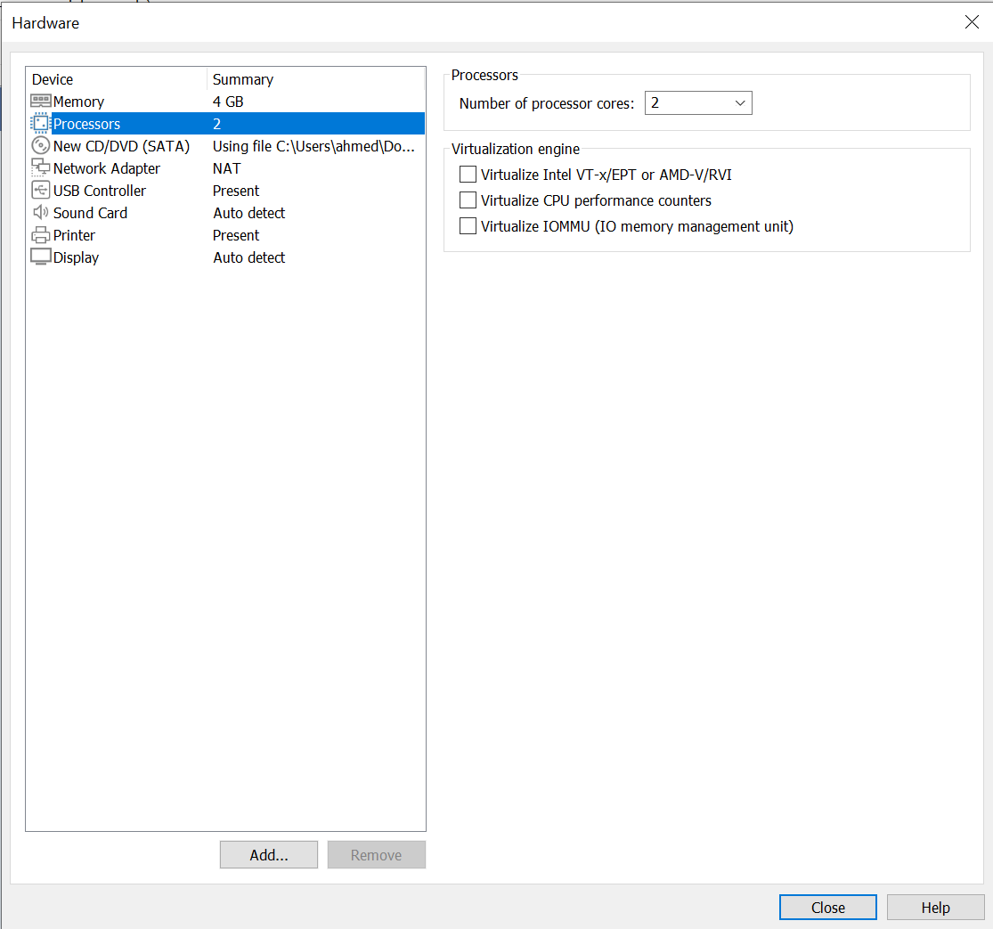

Number of cores are set to 2 by default. That’s enough as well.

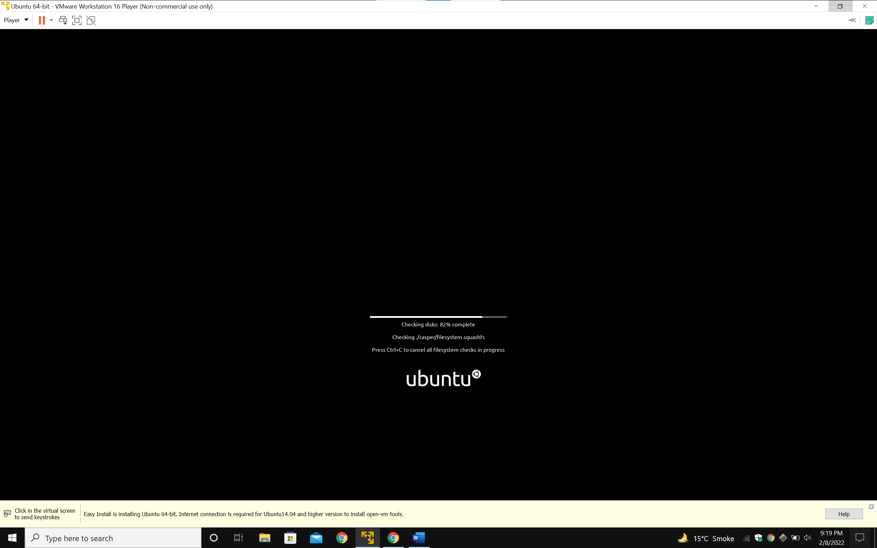

Installation Process.

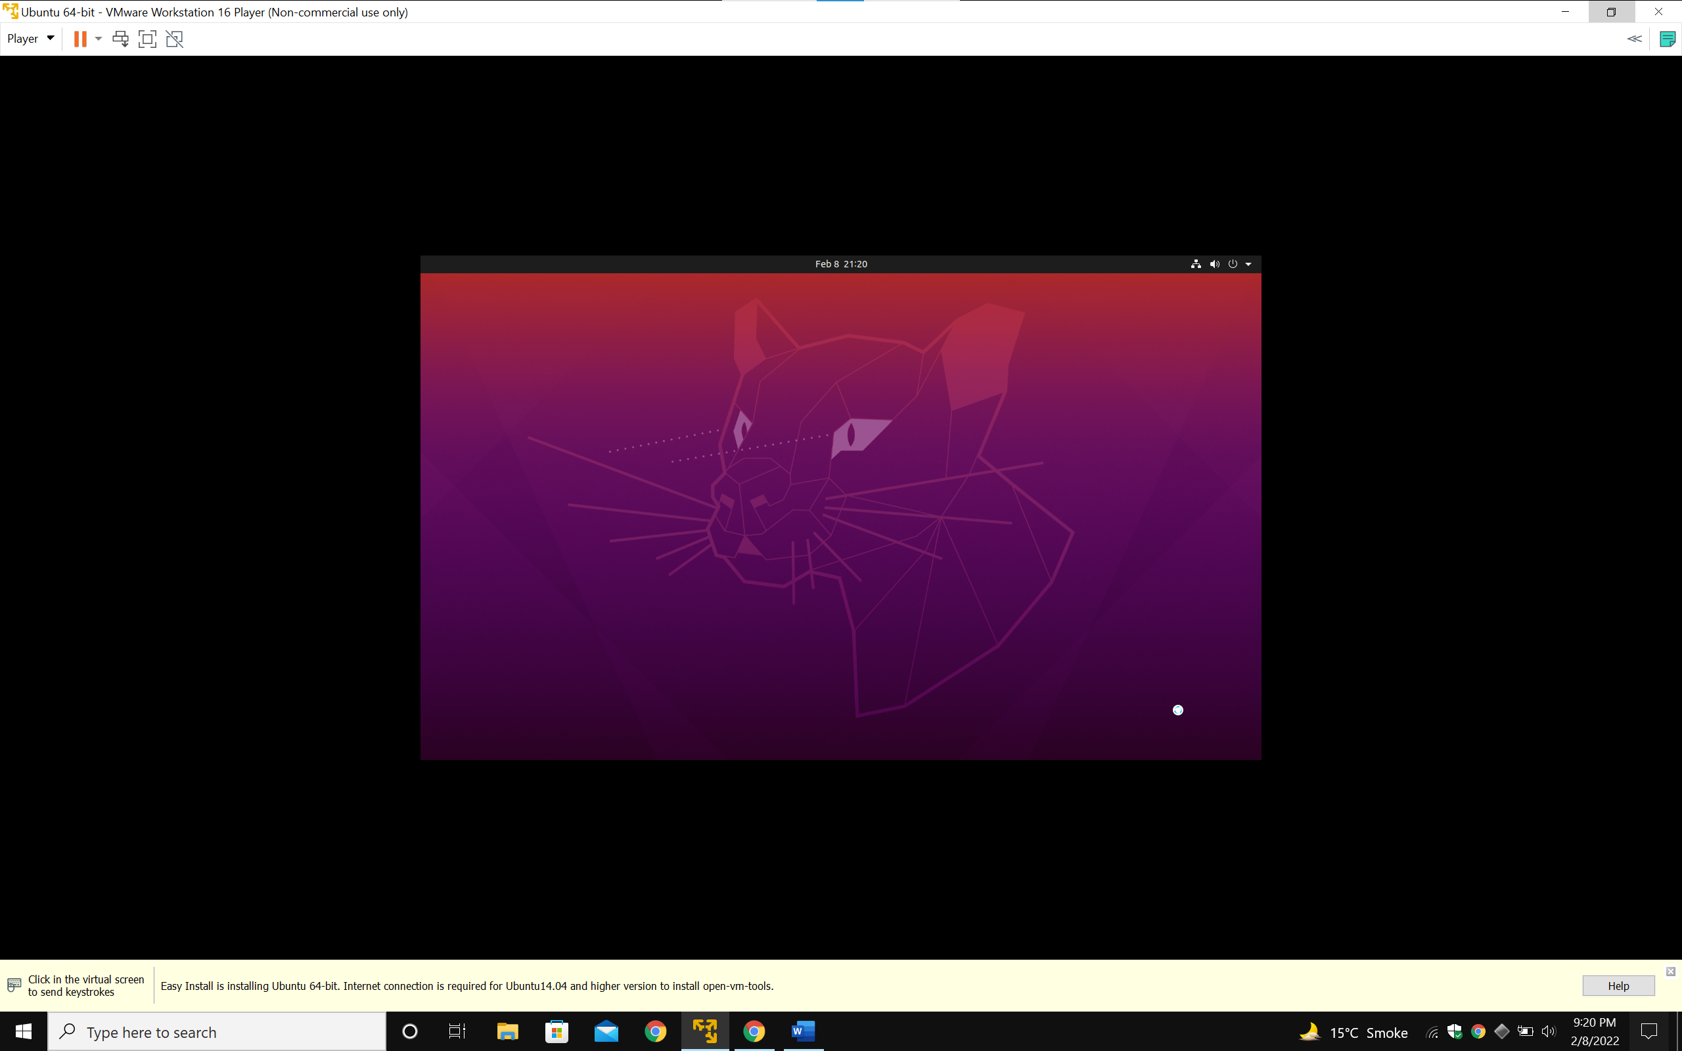

First look through the setup.

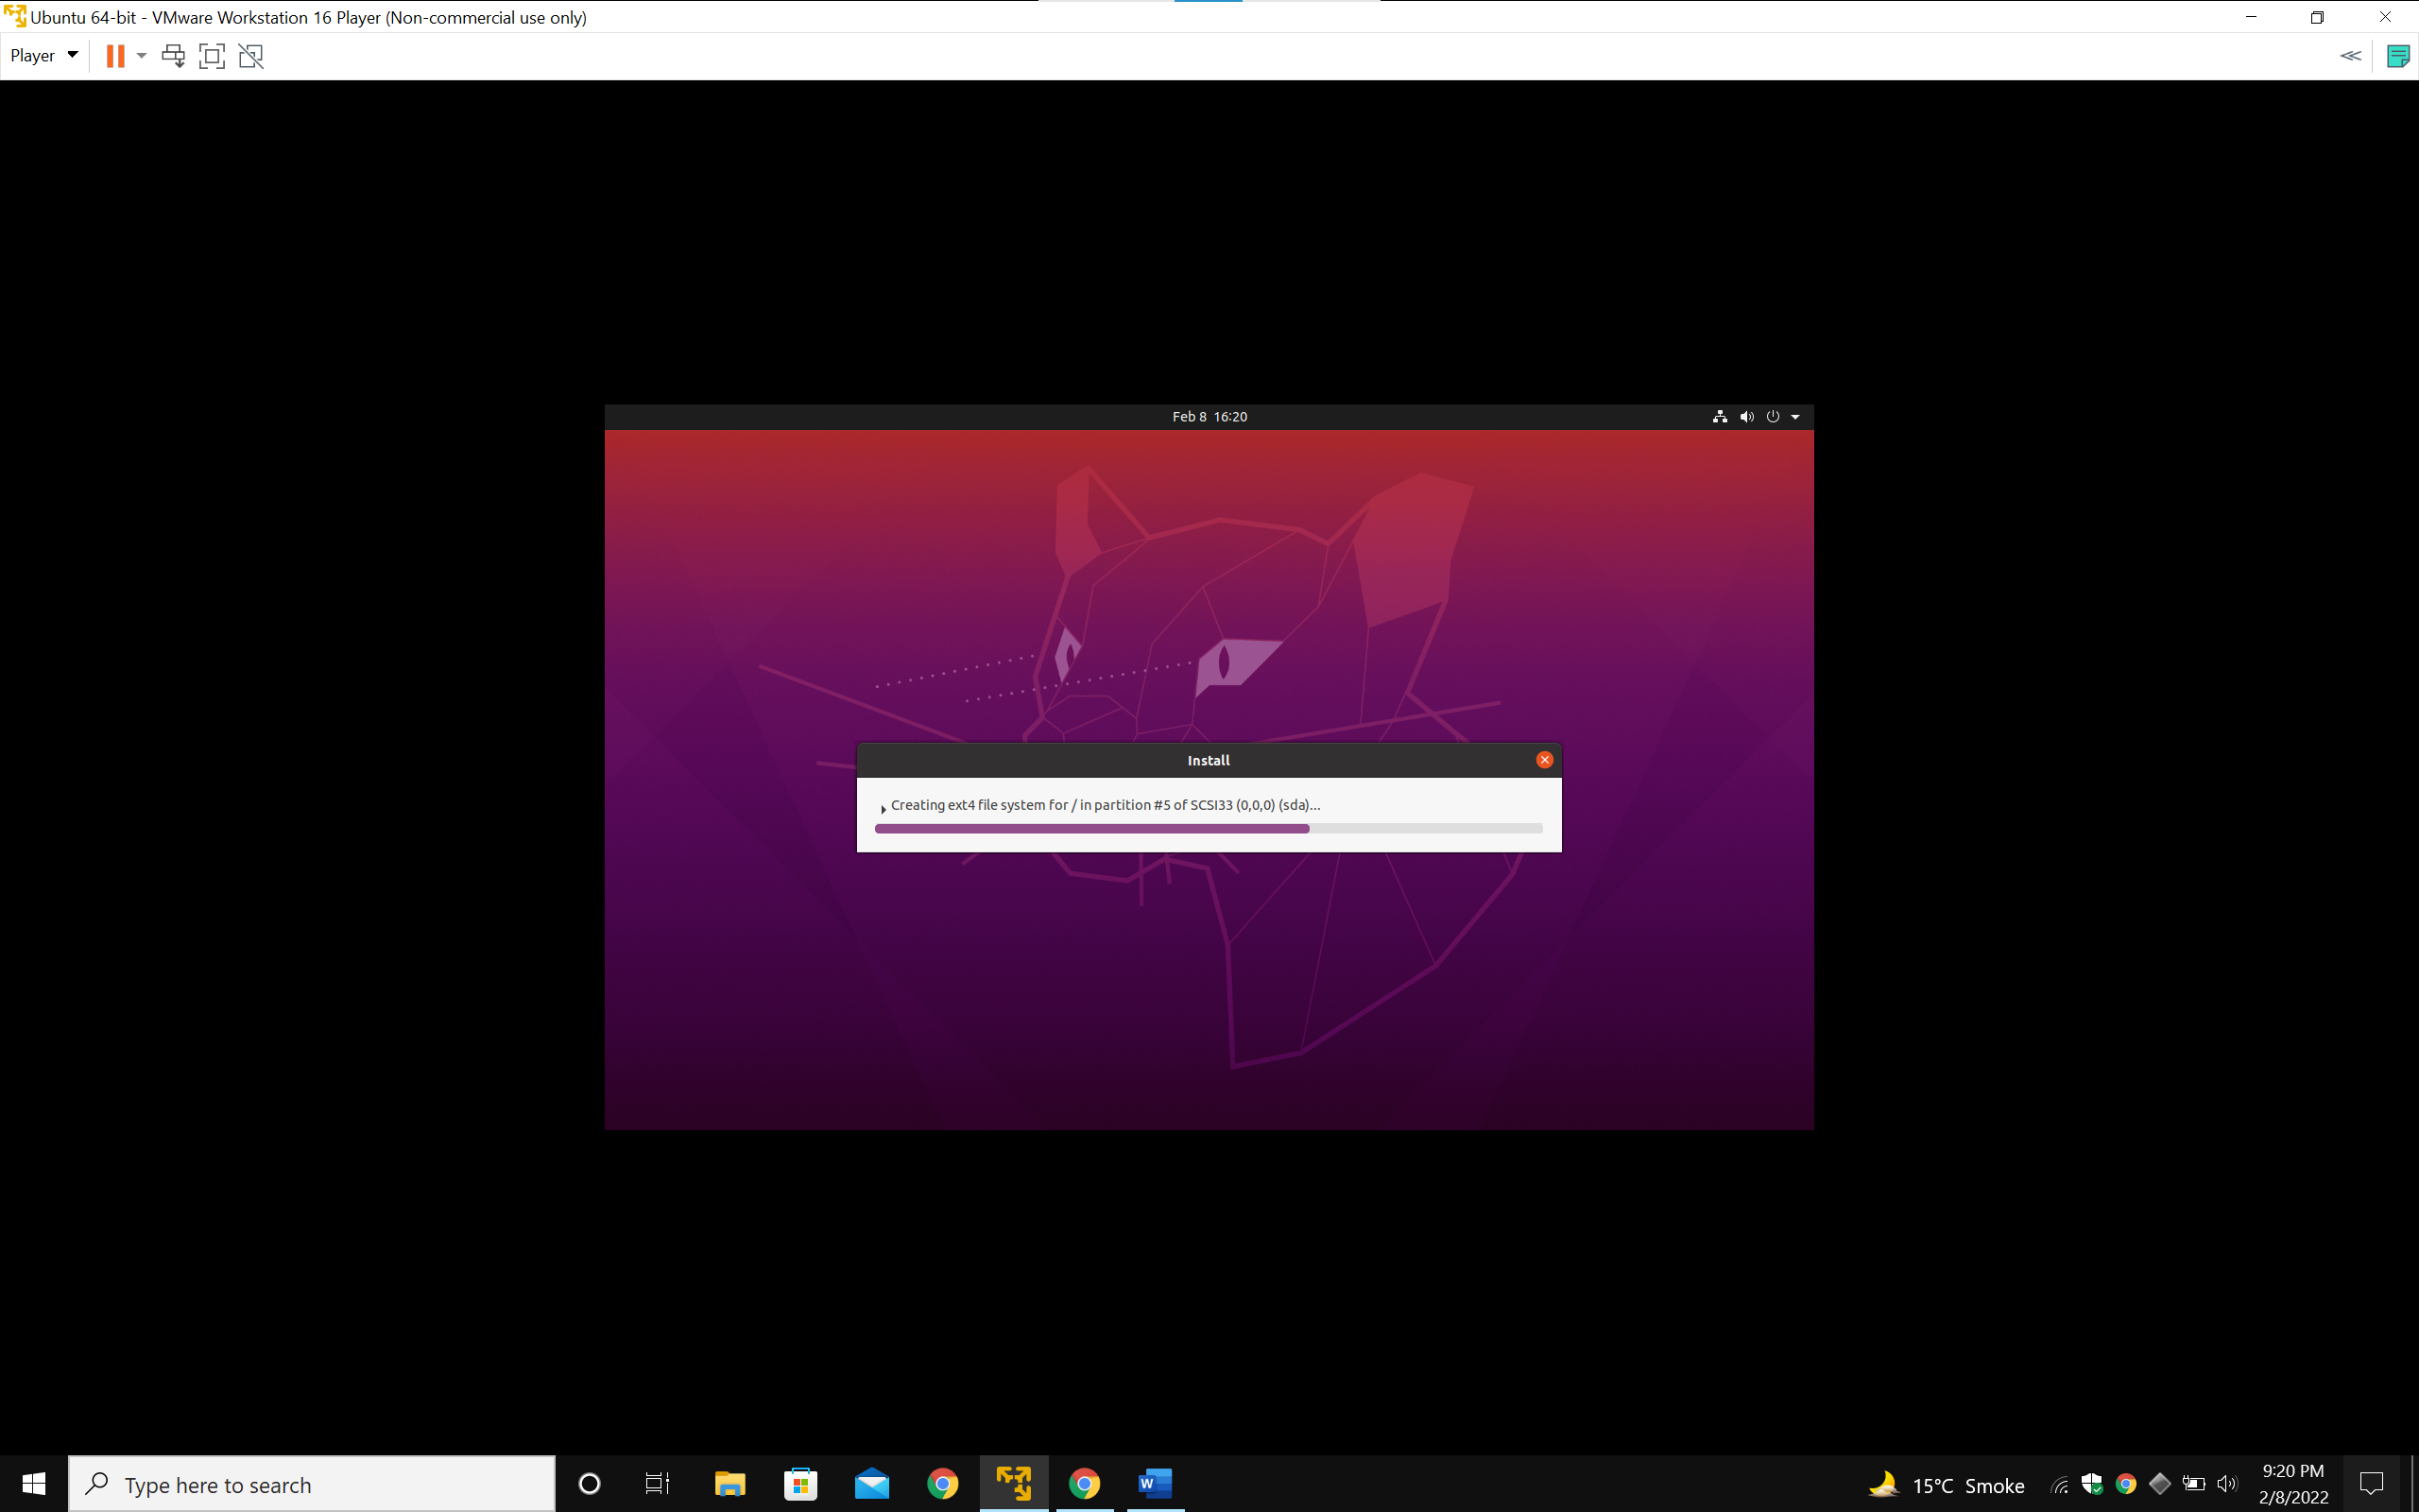

Installation Process.

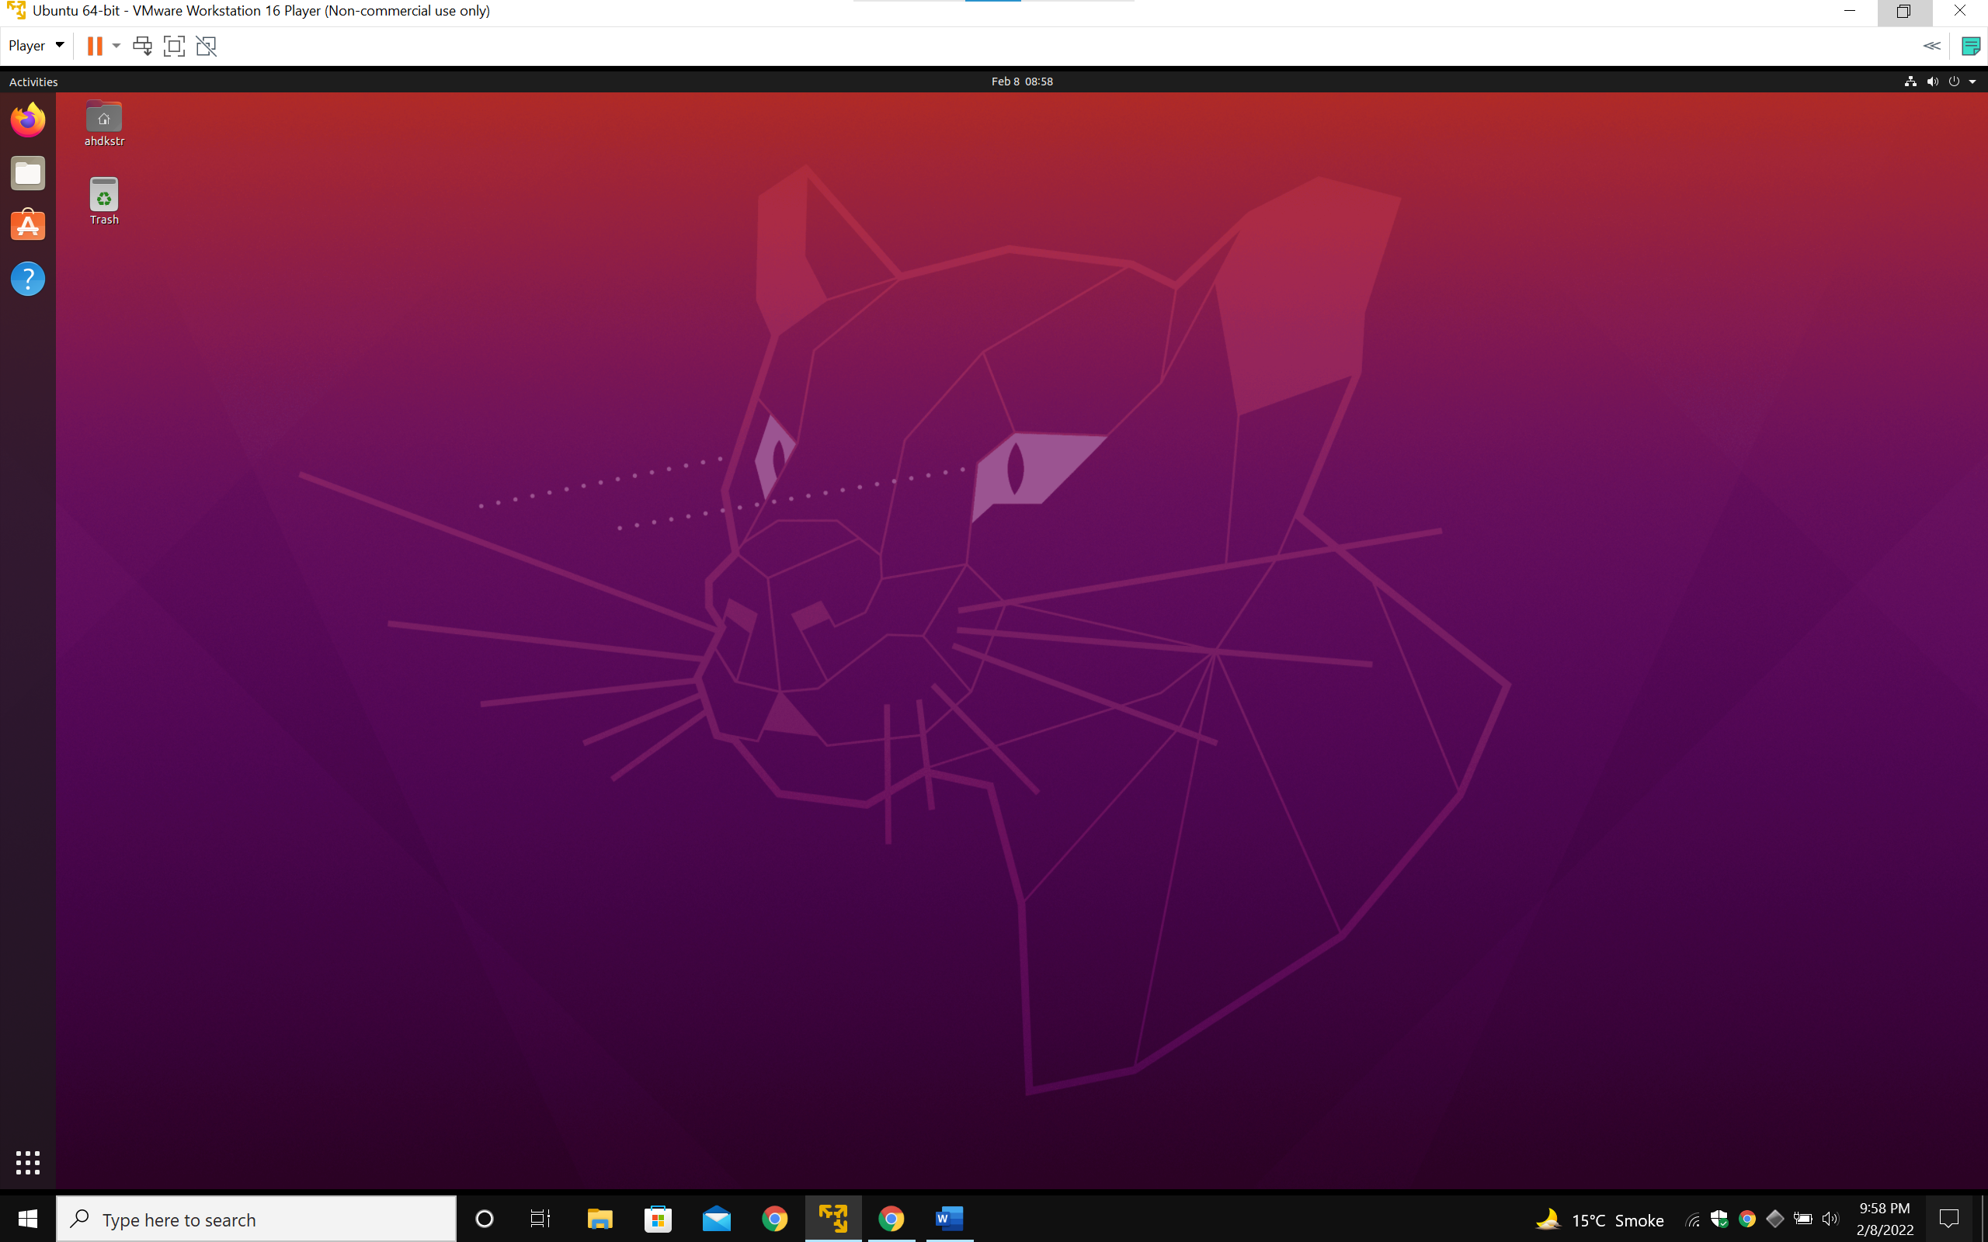

Completed.

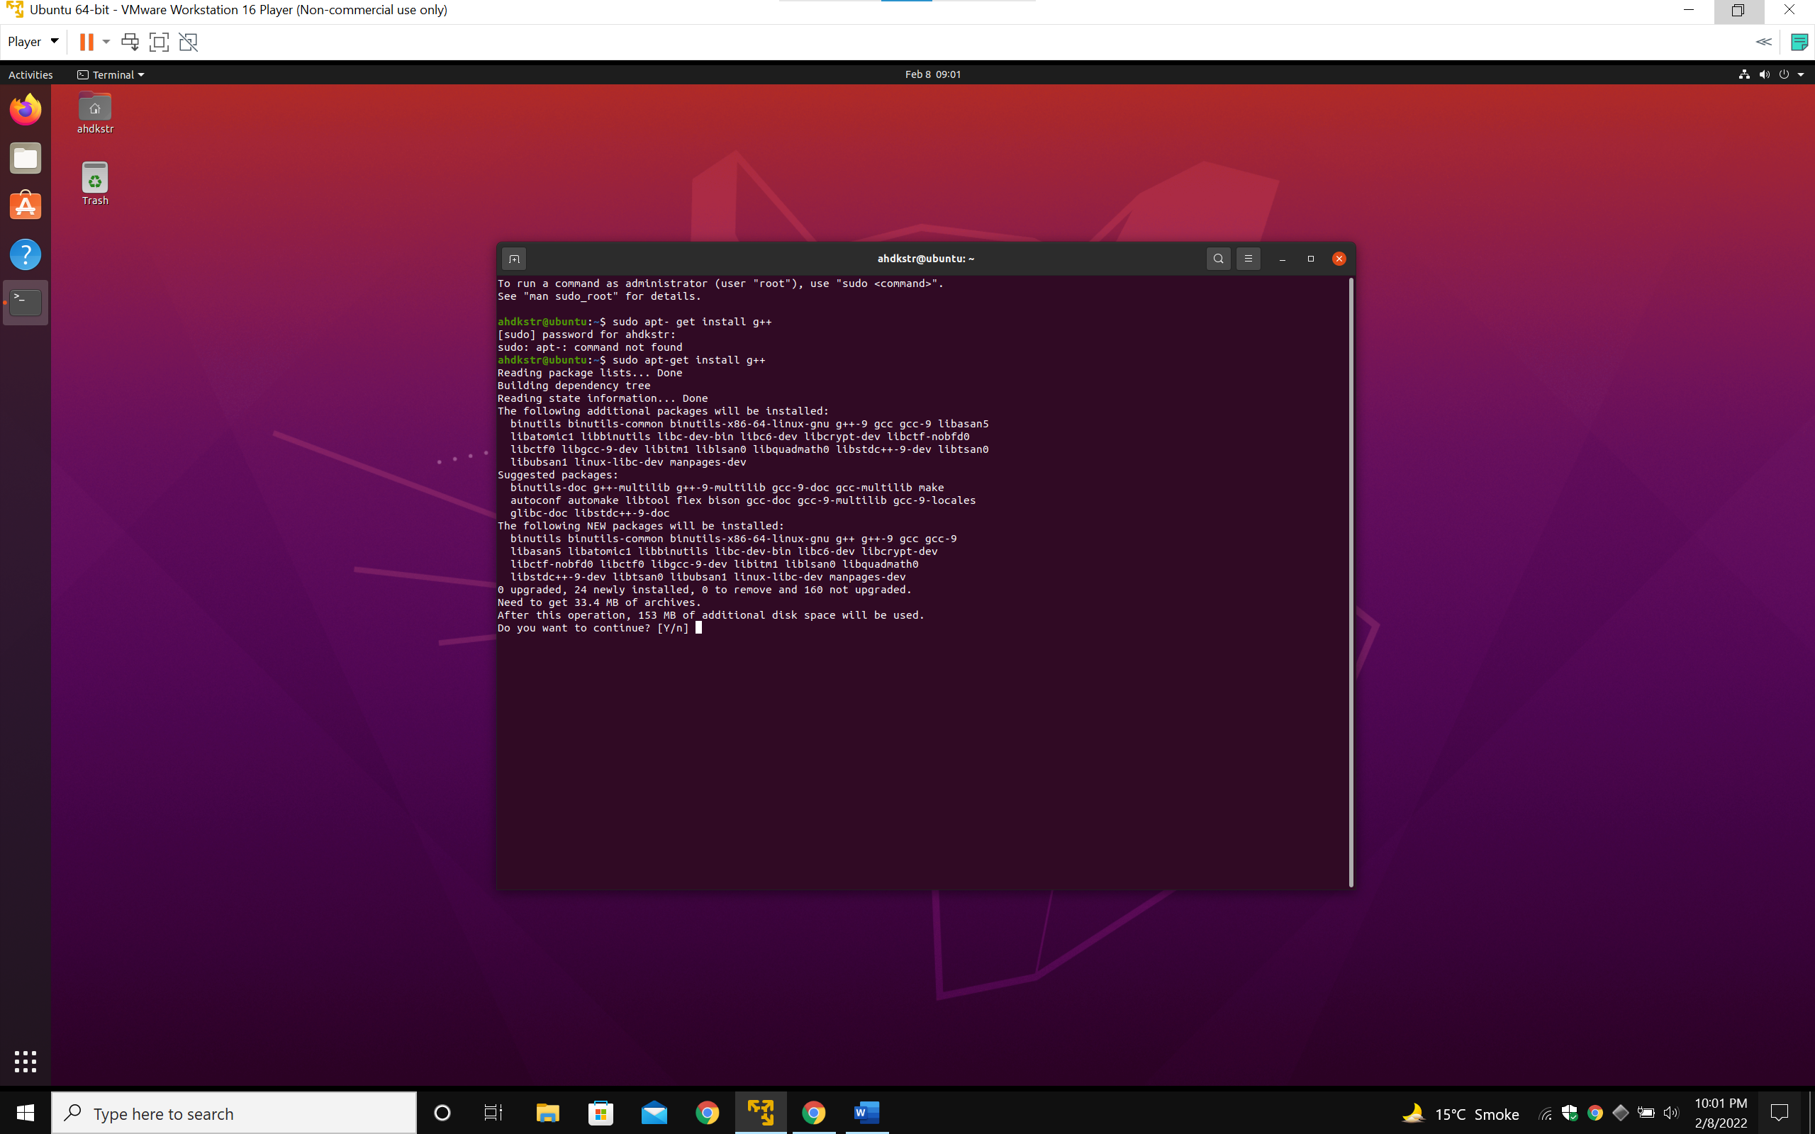

Installing g++ compiler for C++ programming language.

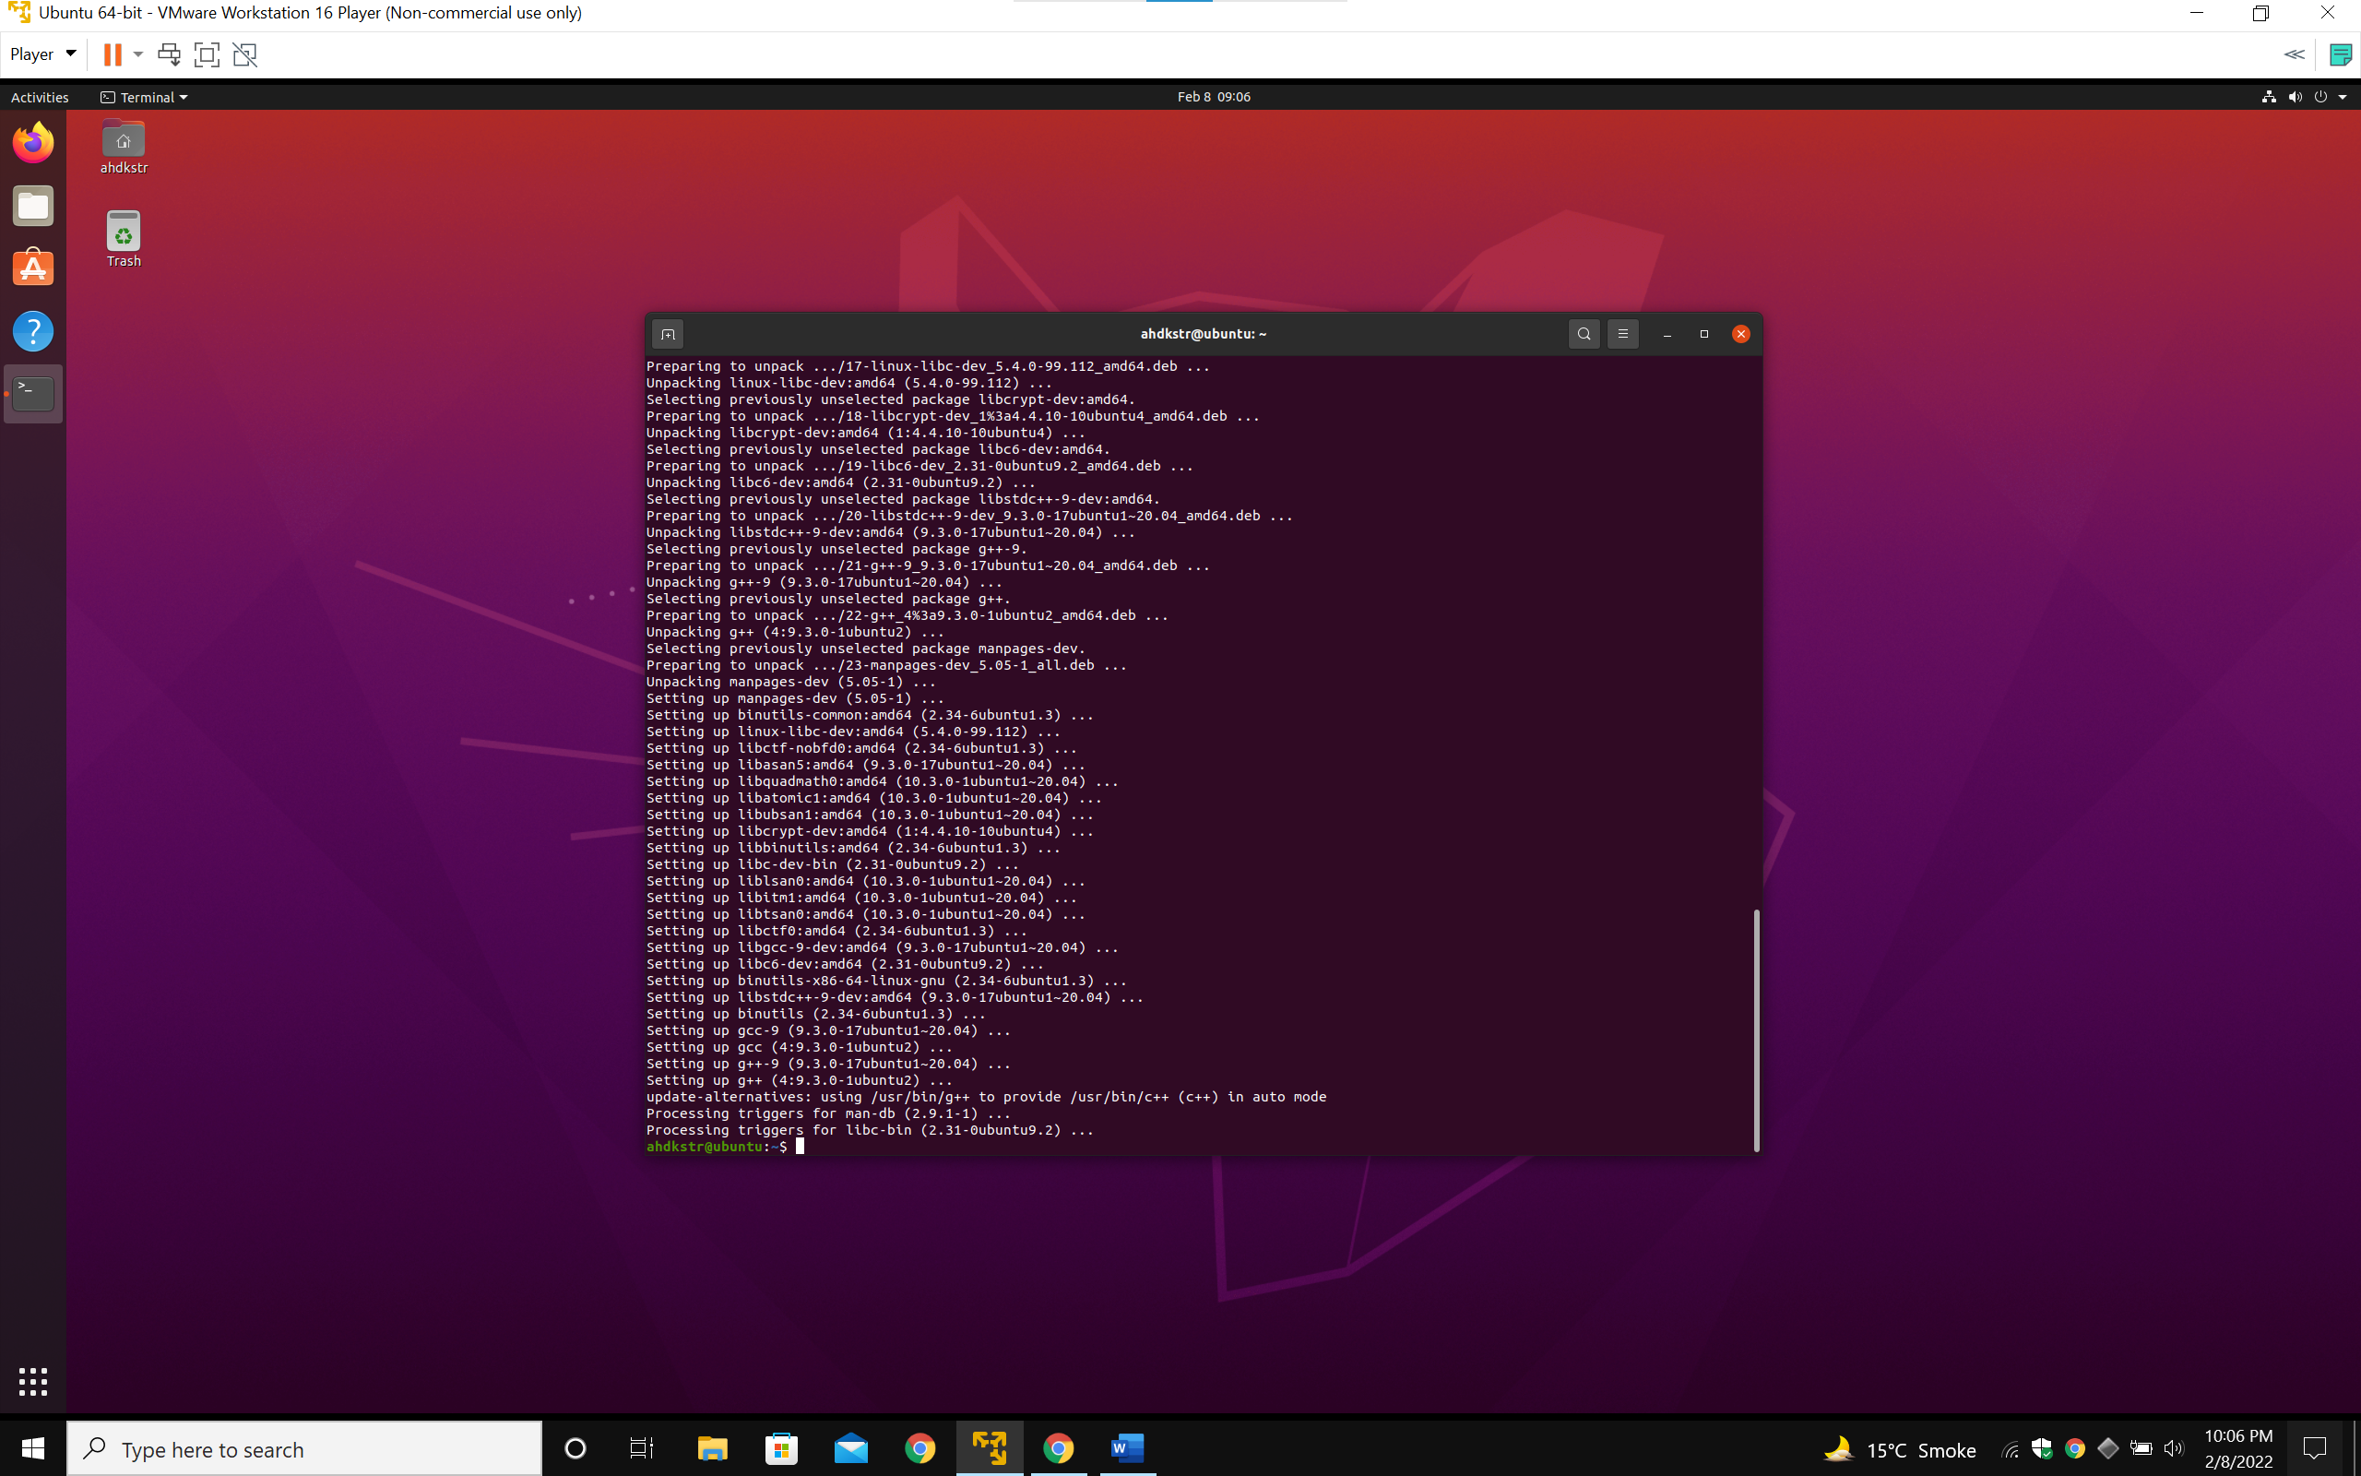

Completed.

1. Writing C program to make a generic code to add subtract and multiply 3 numbers.

Object code created:

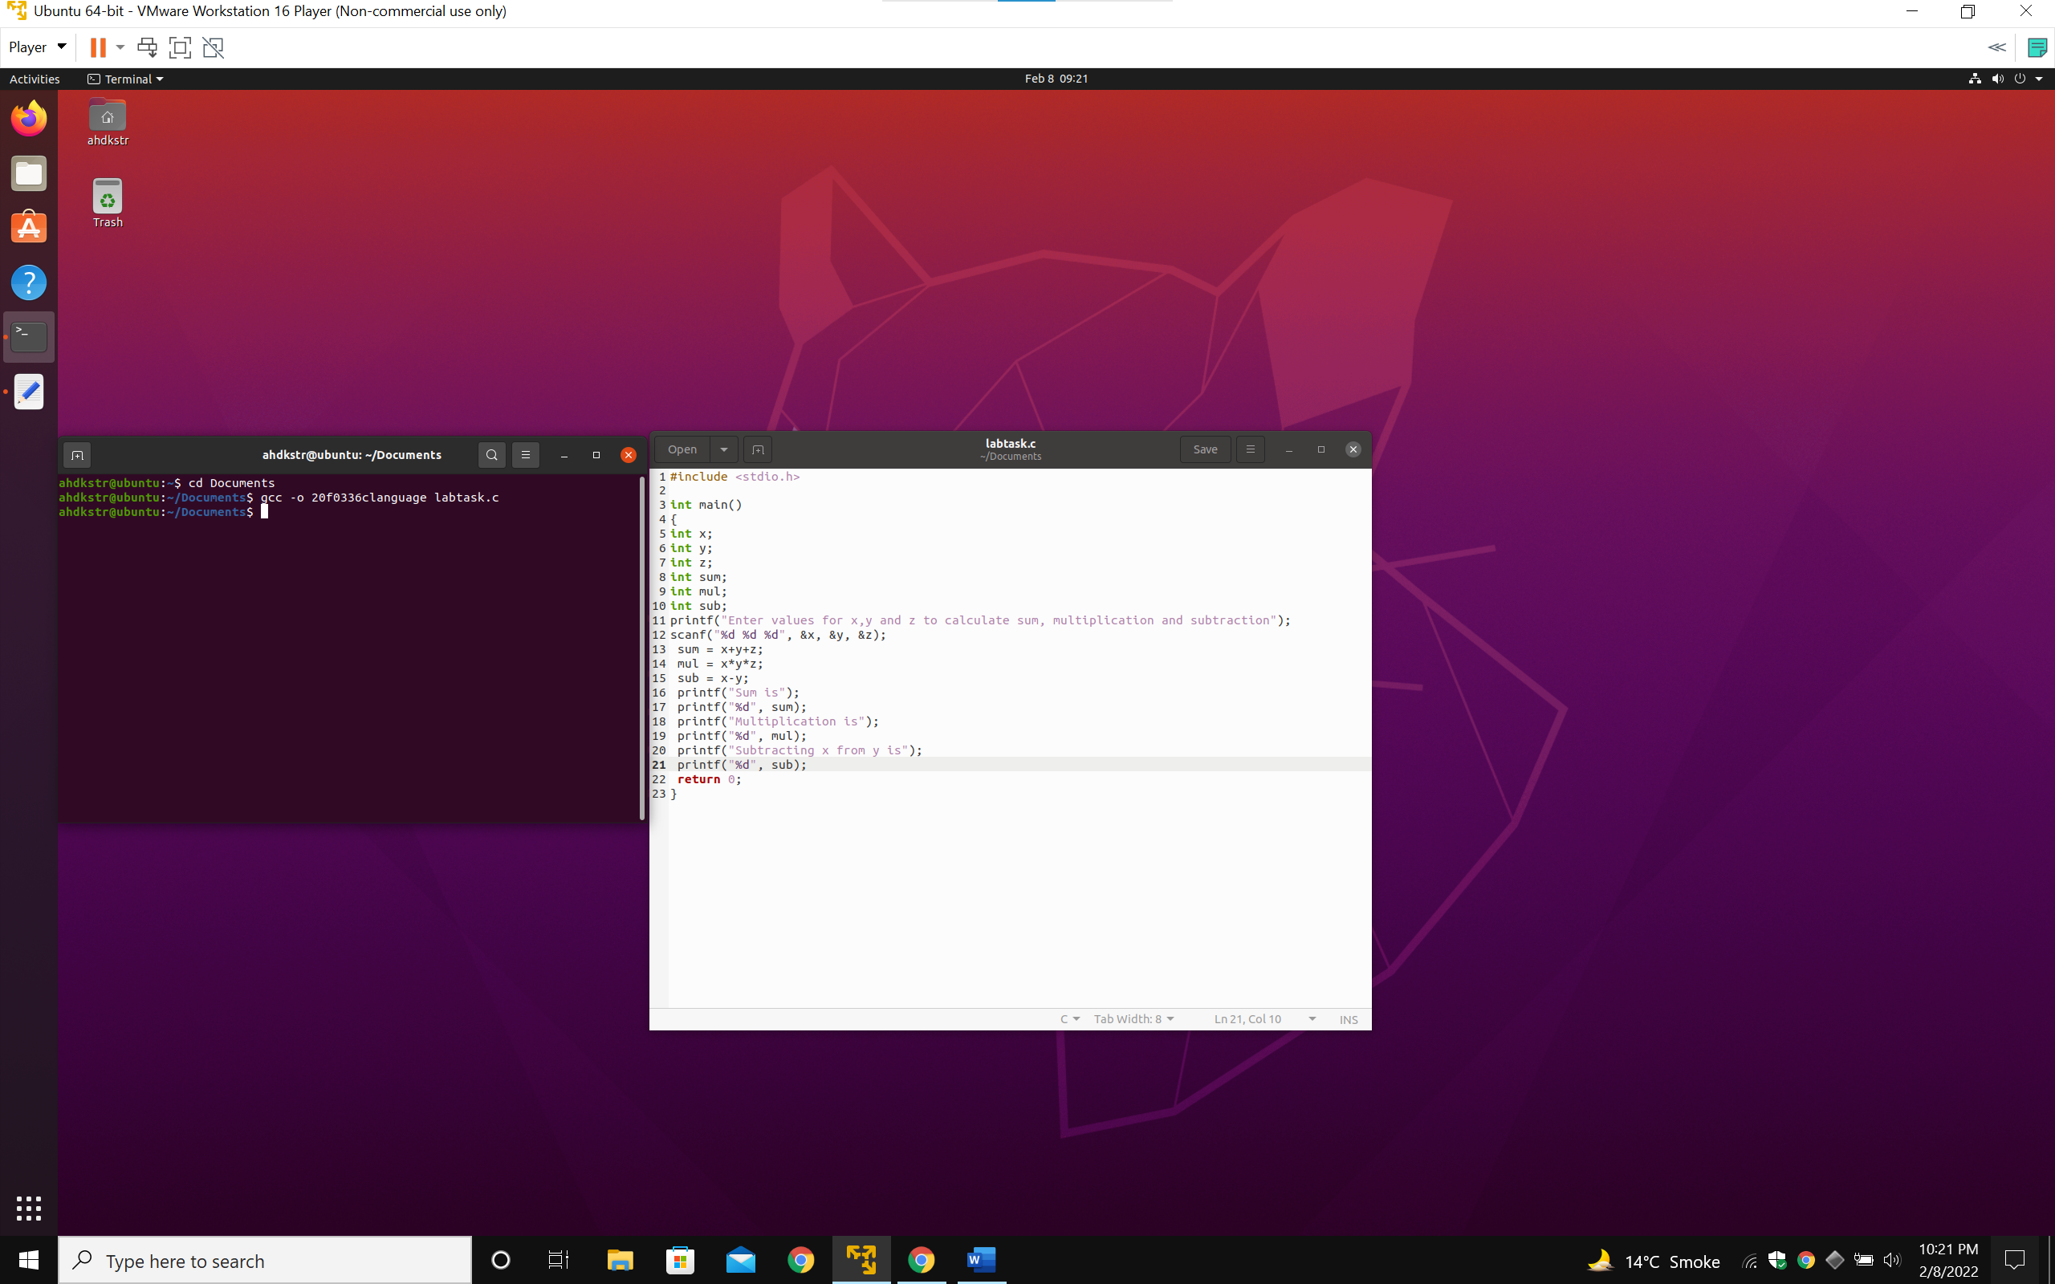

Executing object code...

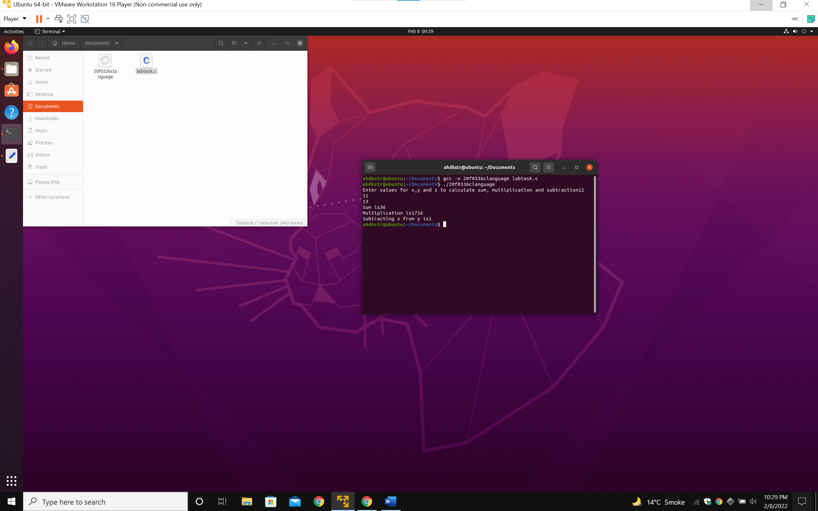

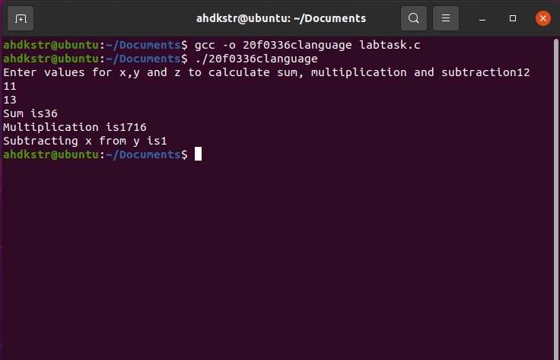

C language Code:

#include <stdio.h>

int main()

{

int x;

int y;

int z;

int sum;

int mul;

int sub;

printf("Enter values for x,y and z to calculate sum, multiplication and subtraction");

scanf("%d %d %d", &x, &y, &z);

sum = x+y+z;

mul = x\*y\*z;

sub = x-y;

printf("Sum is");

printf("%d", sum);

printf("\n");

printf("Multiplication is");

printf("%d", mul);

printf("\n");

printf("Subtracting x from y is");

printf("%d", sub);

printf("\n");

return 0;

}

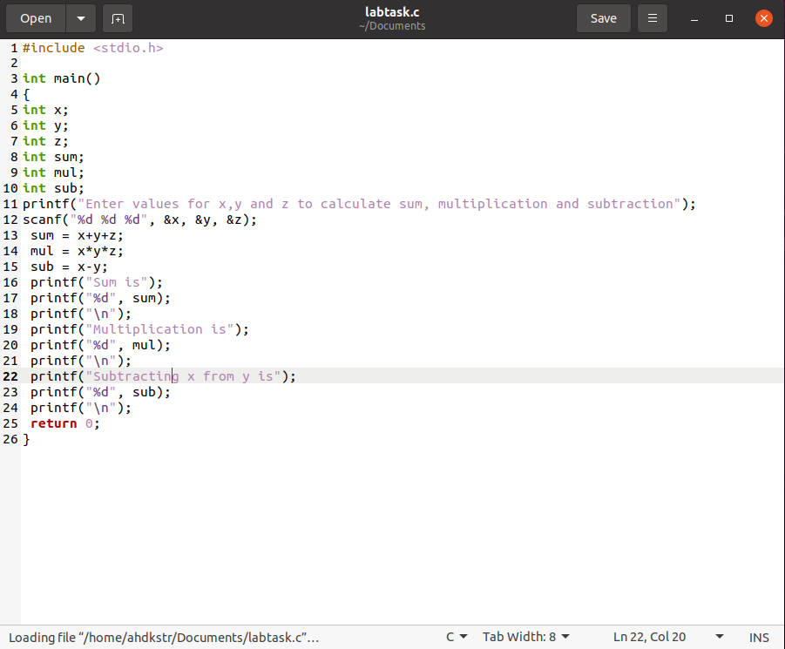

Done.